SECURE SOCKET LAYER(SSL) PROTOCOL
A Project Report Submitted in partial fulfillment for the award of Bachelor’s Degree in Computer Science Engineering.
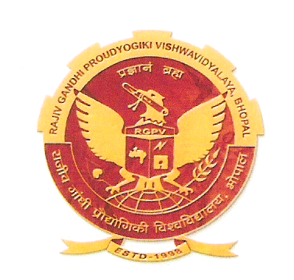
Submitted to RAJIV GANDHI PROUDYOGIKI VISHWAVIDYALAYA BHOPAL (M.P)

MAJOR PROJECT REPORT
Submitted by
APOORV CHITRAY | (0510CS081015)
MARKANDEY SINGH | (0510CS081029)
VIKASH KUMAR | (0510CS081046)

Under the supervision of A.P. Mrs. PUSHPA SINGH(H.O.D)
A.P. Mr. R.S TOMAR
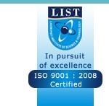

COMPUTER SCIENCE AND ENGINEERING DEPARTMENT LAXMIPATI INSTITUTE OF SCIENCE AND TECHNOLOGY BHOPAL (M.P.) SESSION-2008-12
LAXMIPATI INSTITUTE OF SCIENCE AND TECHNOLOGY, BHOPAL

DEPARTMENT OF COMPUTER SCIENCE AND ENGINEERING

CERTIFICATE

This is to certify that the project work entitled “SECURE SOCKETS LAYER PROTOCOL” has been satisfactorily completed by Apoorv Chitray, Markandey Singh and Vikash Kumar. It is a bona-fide piece of work, carried out under our/ my guidance in the Computer Science and Engineering, Laxmipati Institute of Science and Technology, Bhopal for the partial fulfillment of the Bachelor of Engineering in Computer Science & Engineering during the academic year 2011-12.

Under the Guidance of
Mrs.Pushpa Singh (H.O.D) (Astt. prof) (Department of Computer Science and Engineering)

Mr.R.S Tomar (Astt. prof) (Department of Computer Science and Engineering)

LAXMIPATI INSTITUTE OF SCIENCE AND TECHNOLOGY, BHOPAL

DEPARTMENT OF COMPUTER SCIENCE AND ENGINEERING

CERTIFICATE OF APPROVAL

This foregoing project work is hereby approved as a creditable study of an Engineering Study carried out and presented in a manner satisfactory to warranty its acceptance as a prerequisite to the degree for which it has been submitted. It is understood that by this approval the undersigned do not necessarily endorse or approve any statement made, opinion expressed or conclusion drawn therein, but approve the project only for the purpose for which it has been submitted.

(Internal Examiner) (External Examiner)

PREFACE

This report is the culmination of our odyssey of our whole experience achieved in the programming framework on Advanced Java. This period devoted in the project is marked with the experience of development and bliss.

This major project is an essential part of the L.I.S.T. curriculam. During the project, our belief in our knowledge and understanding of the field of programming has been greatly reinforced. This project is going to benefit us in many ways.

The first benefit is that , it has provided us with an opportunity to know the environment , the practices, the system and the problems in the software development.

It helped us to sharpen our knowledge and skills, developed better appreciation of practical problems of software development and to apply the concepts and techniques to development problems.

This experience is going to help us immensely in our future of advanced software development .It is going help us in the planning of our career under the light of practical experience .Now we have example to relate and it will facilate better and easier learning.

ACKNOWLEDGEMENT

A project like this one involves many people and would be incomplete without the mention of all those people whose guidance and encouragement helped in the successful completion of this project.
We would like to thanks our H.O.D Mrs. PUSHPA SINGH who has been a great source of inspiration for us and without whose humble guidance of project was never to shape. We are also indebted to our guide Mr. R.S TOMAR, for her encouragement, guidance and support.
At the submission of this project work we take the opportunity to express our deep sense of gratitude and indebtedness to the faculty members of Dept. of Computer Science and Engineering, Laxmipati Institute of Science And Technology, Bhopal, for their invaluable, tireless guidance and constructive criticism throughout the development of this project.
It is only due to their constant motivation and moral support that we were able to pull through many difficult phases of the work and bring it to successful completion.
We are also thankful to many people whose timely help but paucity of space is restricting us from mentioning their name.
And finally we also thank to all my colleagues who were constant support during the whole project.

